**What is an Arrhythmia:**

Arrhythmia, also known as cardiac arrhythmia or heart arrhythmia, is a group of conditions in which the [heartbeat](https://en.wikipedia.org/wiki/Cardiac_cycle) is irregular, too fast, or too slow.[[2]](https://en.wikipedia.org/wiki/Arrhythmia#cite_note-NIH2011Def-2) The [heart rate](https://en.wikipedia.org/wiki/Heart_rate) that is too fast – above 100 beats per minute in adults – is called [tachycardia](https://en.wikipedia.org/wiki/Tachycardia), and a heart rate that is too slow – below 60 beats per minute – is called [bradycardia](https://en.wikipedia.org/wiki/Bradycardia) If an arrhythmia results in a heartbeat that is too fast, too slow or too weak to supply the body's needs, this manifests as a lower blood pressure and may cause lightheadedness or dizziness, or syncope ([fainting](https://en.wikipedia.org/wiki/Fainting)).[[16]](https://en.wikipedia.org/wiki/Arrhythmia#cite_note-16)

**Why this matters:**

Arrhythmia affects millions of people.[[4]](https://en.wikipedia.org/wiki/Arrhythmia#cite_note-NIH2011Risk-4) In Europe and North America, as of 2014, atrial fibrillation affects about 2% to 3% of the population.[[8]](https://en.wikipedia.org/wiki/Arrhythmia#cite_note-Zoni2014-8) Atrial fibrillation and atrial flutter resulted in 112,000 deaths in 2013, up from 29,000 in 1990.[[9]](https://en.wikipedia.org/wiki/Arrhythmia#cite_note-GDB2013-9) [Sudden cardiac death](https://en.wikipedia.org/wiki/Sudden_cardiac_death) is the cause of about half of deaths due to [cardiovascular disease](https://en.wikipedia.org/wiki/Cardiovascular_disease) and about 15% of all deaths globally.[[10]](https://en.wikipedia.org/wiki/Arrhythmia#cite_note-Meh2007-10) About 80% of sudden cardiac death is the result of ventricular arrhythmias.[[10]](https://en.wikipedia.org/wiki/Arrhythmia#cite_note-Meh2007-10) Arrhythmias may occur at any age but are more common among older people.[[4]](https://en.wikipedia.org/wiki/Arrhythmia#cite_note-NIH2011Risk-4)

**Types of Arrhythmias:**

There are four main groups of arrhythmia: [extra beats](https://en.wikipedia.org/wiki/Premature_heart_beat), [supraventricular tachycardias](https://en.wikipedia.org/wiki/Supraventricular_tachycardia), [ventricular arrhythmias](https://en.wikipedia.org/wiki/Ventricular_arrhythmia) and [bradyarrhythmias](https://en.wikipedia.org/wiki/Bradyarrhythmia) Extra beats include [premature atrial contractions](https://en.wikipedia.org/wiki/Premature_atrial_contraction), [premature ventricular contractions](https://en.wikipedia.org/wiki/Premature_ventricular_contraction) and [premature junctional contractions](https://en.wikipedia.org/wiki/Premature_junctional_contractions).[[3]](https://en.wikipedia.org/wiki/Arrhythmia#cite_note-NIH2011Type-3) Supraventricular tachycardias include [atrial fibrillation](https://en.wikipedia.org/wiki/Atrial_fibrillation), [atrial flutter](https://en.wikipedia.org/wiki/Atrial_flutter) and [paroxysmal supraventricular tachycardia](https://en.wikipedia.org/wiki/Paroxysmal_supraventricular_tachycardia).[[3]](https://en.wikipedia.org/wiki/Arrhythmia#cite_note-NIH2011Type-3) Ventricular arrhythmias include [ventricular fibrillation](https://en.wikipedia.org/wiki/Ventricular_fibrillation) and [ventricular tachycardia](https://en.wikipedia.org/wiki/Ventricular_tachycardia).[[3]](https://en.wikipedia.org/wiki/Arrhythmia#cite_note-NIH2011Type-3)[[7]](https://en.wikipedia.org/wiki/Arrhythmia#cite_note-Martin2012-7) Arrhythmias are due to problems with the [electrical conduction system of the heart](https://en.wikipedia.org/wiki/Electrical_conduction_system_of_the_heart).[[2]](https://en.wikipedia.org/wiki/Arrhythmia#cite_note-NIH2011Def-2) Arrhythmias may also occur in children, however, the normal range for the heart rate is different and depends on age.[[3]](https://en.wikipedia.org/wiki/Arrhythmia#cite_note-NIH2011Type-3) A number of tests can help with diagnosis including an [electrocardiogram](https://en.wikipedia.org/wiki/Electrocardiogram) (ECG) and [Holter monitor](https://en.wikipedia.org/wiki/Holter_monitor).[[5]](https://en.wikipedia.org/wiki/Arrhythmia#cite_note-NIH2011Diag-5)

Arrhythmia may be classified by rate ([tachycardia](https://en.wikipedia.org/wiki/Tachycardia), [bradycardia](https://en.wikipedia.org/wiki/Bradycardia)), mechanism (automaticity, re-entry, triggered) or duration (isolated [premature beats](https://en.wikipedia.org/wiki/Premature_heart_beat); couplets; runs, that is 3 or more beats; non-sustained= less than 30 seconds or sustained= over 30 seconds).

It is also appropriate to classify by site of origin:

**Re-entrant arrhythmias**

Normally, the impulse will spread through the heart quickly enough that each cell will respond only once. if conduction is abnormally slow in some areas (for example in heart damage) so the myocardial cells are unable to activate the fast sodium channel, part of the impulse will arrive late and potentially be treated as a new impulse (akas re-entry arrhythmia) As a sort of re-entry, vortices of excitation in the myocardium ([autowave vortices](https://en.wikipedia.org/wiki/Autowave)) are considered to be the main mechanism of life-threatening cardiac arrhythmias.[[21]](https://en.wikipedia.org/wiki/Arrhythmia#cite_note-b-Mandel-1995-21) In particular, the [autowave reverberator](https://en.wikipedia.org/wiki/Autowave_reverberator) is common in the thin walls of the atria, sometimes resulting in [atrial flutter](https://en.wikipedia.org/wiki/Atrial_flutter). Although [omega-3 fatty acids](https://en.wikipedia.org/wiki/Omega-3_fatty_acid) from [fish oil](https://en.wikipedia.org/wiki/Fish_oil) can be protective against arrhythmias, they can facilitate re-entrant arrhythmias

When an entire chamber of the heart is involved in multiple micro-reentry circuits and is, therefore, quivering with chaotic electrical impulses, it is said to be in fibrillation. Fibrillation can affect the atrium ([atrial fibrillation](https://en.wikipedia.org/wiki/Atrial_fibrillation)) or the ventricle ([ventricular fibrillation](https://en.wikipedia.org/wiki/Ventricular_fibrillation)): ventricular fibrillation is imminently life-threatening.  If left untreated, [ventricular fibrillation](https://en.wikipedia.org/wiki/Ventricular_fibrillation) (VF, or V-fib) can lead to death within minutes. When a heart goes into V-fib, effective pumping of the blood stops. An individual suffering from it will not survive unless [cardiopulmonary resuscitation](https://en.wikipedia.org/wiki/Cardiopulmonary_resuscitation) (CPR) and [defibrillation](https://en.wikipedia.org/wiki/Defibrillation) are provided immediately. CPR can prolong the survival of the [brain](https://en.wikipedia.org/wiki/Brain) in the lack of a normal pulse, but defibrillation is the only intervention that can restore a healthy heart rhythm. Defibrillation is performed by applying an electric shock to the heart, which resets the cells, permitting a normal beat to re-establish itself.

**Worse Case Arrhythmias:**

[Sudden arrhythmic death syndrome](https://en.wikipedia.org/wiki/Sudden_arrhythmic_death_syndrome) (SADS), is a term used as part of sudden unexpected death syndrome to describe sudden [death](https://en.wikipedia.org/wiki/Death) because of [cardiac arrest](https://en.wikipedia.org/wiki/Cardiac_arrest) occasioned by an arrhythmia in the presence or absence of any structural heart disease on autopsy. The most common cause of sudden death in the US is [coronary artery disease](https://en.wikipedia.org/wiki/Coronary_artery_disease) specifically because of poor oxygenation of the heart muscle, that is [myocardial ischemia](https://en.wikipedia.org/wiki/Myocardial_ischemia) or a [heart attack](https://en.wikipedia.org/wiki/Myocardial_infarction) [[11]](https://en.wikipedia.org/wiki/Arrhythmia#cite_note-11) Approximately 180,000 to 250,000 people die suddenly of this cause every year in the US. SADS may occur from other causes. There are many inherited conditions and heart diseases that can affect young people which can subsequently cause sudden death without advance symptoms.[[12]](https://en.wikipedia.org/wiki/Arrhythmia#cite_note-12)

Causes of SADS in young people include [viral myocarditis](https://en.wikipedia.org/wiki/Viral_myocarditis), [long QT syndrome](https://en.wikipedia.org/wiki/Long_QT_syndrome), [Brugada syndrome](https://en.wikipedia.org/wiki/Brugada_syndrome" \o "Brugada syndrome), [Catecholaminergic polymorphic ventricular tachycardia](https://en.wikipedia.org/wiki/Catecholaminergic_polymorphic_ventricular_tachycardia), [hypertrophic cardiomyopathy](https://en.wikipedia.org/wiki/Hypertrophic_cardiomyopathy) and [arrhythmogenic right ventricular dysplasia](https://en.wikipedia.org/wiki/Arrhythmogenic_right_ventricular_dysplasia).[[13]](https://en.wikipedia.org/wiki/Arrhythmia#cite_note-a-_Chugh-2008-13)[[14]](https://en.wikipedia.org/wiki/Arrhythmia#cite_note-14)

**How to Recognize Arrhythmias:**

Cardiac arrhythmia is often first detected by simple but nonspecific means listening to the hearbeat with a stethoscope or feeling for peripheral pulses. These cannot usually diagnose specific arrhythmia but can give a general indication of the heart rate and whether it is regular or irregular.

The simplest specific diagnostic test for assessment of heart rhythm is the [electrocardiogram](https://en.wikipedia.org/wiki/Electrocardiogram) (abbreviated ECG or EKG). A [Holter monitor](https://en.wikipedia.org/wiki/Holter_monitor) is an EKG recorded over a 24-hour period, to detect arrhythmias that may happen briefly and unpredictably throughout the day.

For more detail: Transesophageal atrial stimulation (TAS) instead uses an electrode inserted through the [esophagus](https://en.wikipedia.org/wiki/Esophagus" \o "Esophagus) to a part where the distance to the posterior wall of the [left atrium](https://en.wikipedia.org/wiki/Left_atrium) is only approximately 5–6 mm (remaining constant in people of different age and weight).[[24]](https://en.wikipedia.org/wiki/Arrhythmia#cite_note-MeigasKaik2008-24) Transesophageal atrial stimulation can differentiate between [atrial flutter](https://en.wikipedia.org/wiki/Atrial_flutter), [AV nodal reentrant tachycardia](https://en.wikipedia.org/wiki/AV_nodal_reentrant_tachycardia) and orthodromic [atrioventricular reentrant tachycardia](https://en.wikipedia.org/wiki/Atrioventricular_reentrant_tachycardia).[[25]](https://en.wikipedia.org/wiki/Arrhythmia#cite_note-PehrsonBlomstr%C3%B6-LUNDQVIST1994-25) It can also evaluate the risk in people with [Wolff–Parkinson–White syndrome](https://en.wikipedia.org/wiki/Wolff%E2%80%93Parkinson%E2%80%93White_syndrome), as well as terminate [supraventricular tachycardia](https://en.wikipedia.org/wiki/Supraventricular_tachycardia) caused by [re-entry](https://en.wikipedia.org/wiki/Cardiac_arrhythmia#Re-entry)

**Understanding the data:**

Each heart beat originates as an electrical impulse in the SA node, which causes both atria to contract then activates the AV node (the only electrical connection between the atria and ventricles). The impulse spreads through both ventricles causing a synchronised contraction of the heart muscle (akas “pulse”).

EKG – what can it tell us (SA node, AV node, ventricles)

It is a graph of [voltage](https://en.wikipedia.org/wiki/Voltage) versus time of the electrical activity of the [heart](https://en.wikipedia.org/wiki/Heart)[[4]](https://en.wikipedia.org/wiki/Electrocardiography#cite_note-5) using [electrodes](https://en.wikipedia.org/wiki/Electrode) placed on the skin. These electrodes detect the small electrical changes. Changes in the normal ECG pattern occur in numerous cardiac abnormalities, Interpretation of the ECG is ultimately that of pattern recognition.

Normal rhythm produces four entities – a P wave, a QRS complex, a T wave, and a U wave – that each have a fairly unique pattern.

* The P wave represents atrial depolarization.
* The QRS complex represents ventricular depolarization.
* The T wave represents ventricular repolarization.
* The U wave represents papillary muscle repolarization.

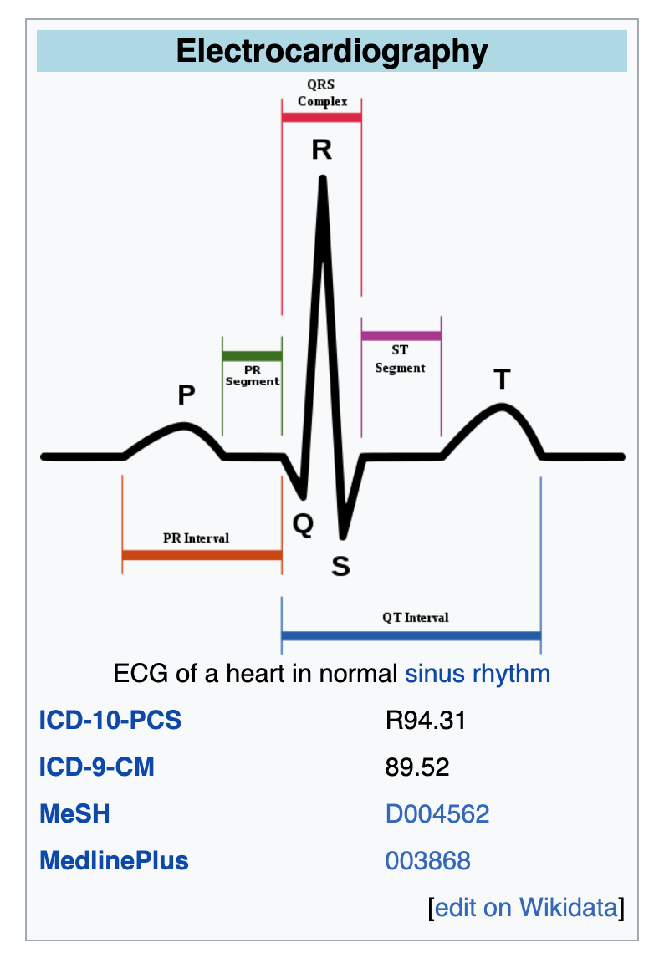 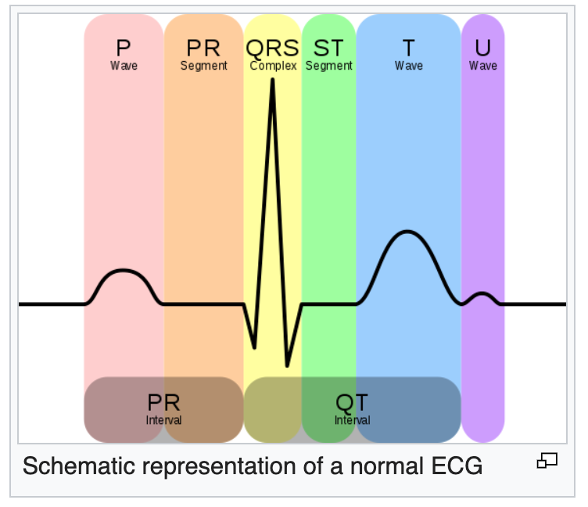

In a conventional 12-lead ECG, ten electrodes are placed on the patient's limbs and on the surface of the chest. The overall [magnitude](https://en.wikipedia.org/wiki/Magnitude_(mathematics)) of the heart's [electrical potential](https://en.wikipedia.org/wiki/Electrical_potential) is then measured from twelve different angles ("leads") and is recorded over a period of time (usually ten seconds). In this way, the overall magnitude and direction of the heart's electrical depolarization is captured at each moment throughout the [cardiac cycle](https://en.wikipedia.org/wiki/Cardiac_cycle).[[5]](https://en.wikipedia.org/wiki/Electrocardiography#cite_note-LHC-6)

During each heartbeat, a healthy heart has an orderly progression of depolarization (described above - Each heart beat originates as an electrical impulse in the SA node, which causes both atria to contract then activates the AV node (the only electrical connection between the atria and ventricles). The impulse spreads through both ventricles causing a synchronised contraction of the heart muscle (akas “pulse”).

) This orderly pattern of depolarization (SA node, AV node, ventricles) gives rise to the characteristic ECG tracing.

ECGs can be recorded as short intermittent tracings (usually 10 second) or *continuous* ECG monitoring

**Examples of EKGs and what they mean:**

(Sinus arrhythmia is alternating mild acceleration and deccletation of the heart rate. Bradycardia slow rhythm (less than 60 beats/min) Tachycardias – fater tahhn100 beats/min. SA starts impulse, but any other node can start it instead – ectopic focus.

Problems with the electrical pathway of the heart can cause very fast or even deadly arrhythmias. [Wolff–Parkinson–White syndrome](https://en.wikipedia.org/wiki/Wolff%E2%80%93Parkinson%E2%80%93White_syndrome) is due to an extra pathway in the heart that is made up of electrical muscle tissue. Long QT Syndrom is a condition which affects [repolarization](https://en.wikipedia.org/wiki/Repolarization) of the [heart](https://en.wikipedia.org/wiki/Heart) after a [heartbeat](https://en.wikipedia.org/wiki/Cardiac_cycle).[[4]](https://en.wikipedia.org/wiki/Long_QT_syndrome#cite_note-Levine2008-4) It results in an increased risk of an [irregular heartbeat](https://en.wikipedia.org/wiki/Cardiac_arrhythmia) which can result in [fainting](https://en.wikipedia.org/wiki/Syncope_(medicine)), [drowning](https://en.wikipedia.org/wiki/Drowning), or [sudden death](https://en.wikipedia.org/wiki/Sudden_cardiac_death).[[1]](https://en.wikipedia.org/wiki/Long_QT_syndrome#cite_note-GARD2017-1) These episodes can be triggered by exercise or stress.[[5]](https://en.wikipedia.org/wiki/Long_QT_syndrome#cite_note-NIH2017-5) Other associated symptoms may include [hearing loss](https://en.wikipedia.org/wiki/Hearing_loss) in certain types of long QT syndrome.[[1]](https://en.wikipedia.org/wiki/Long_QT_syndrome#cite_note-GARD2017-1)

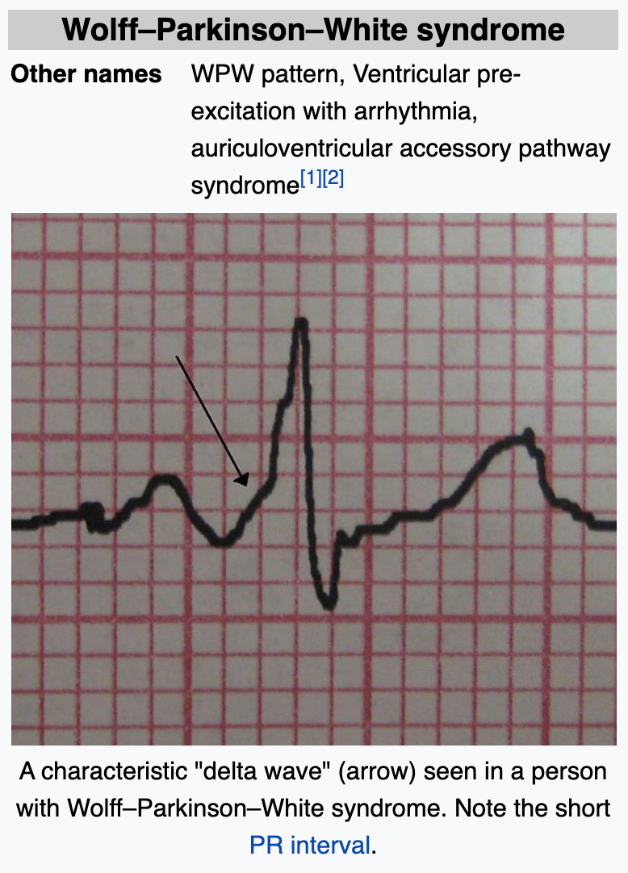 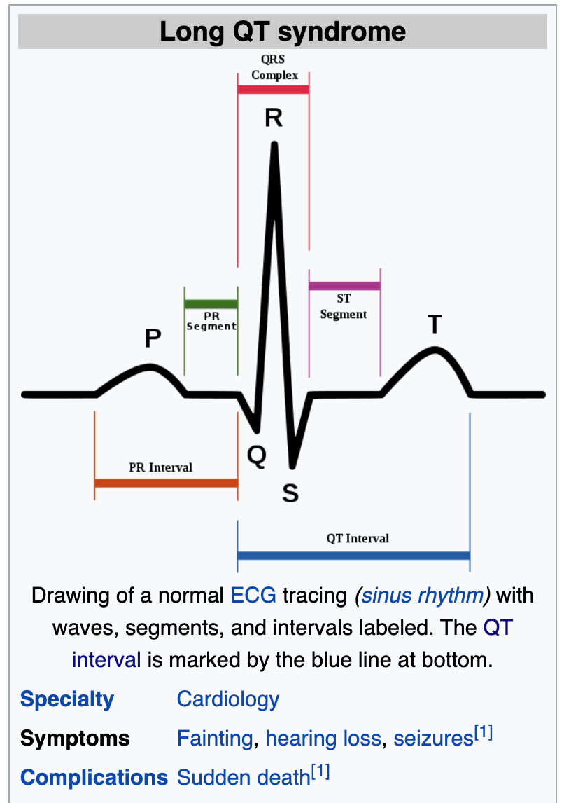 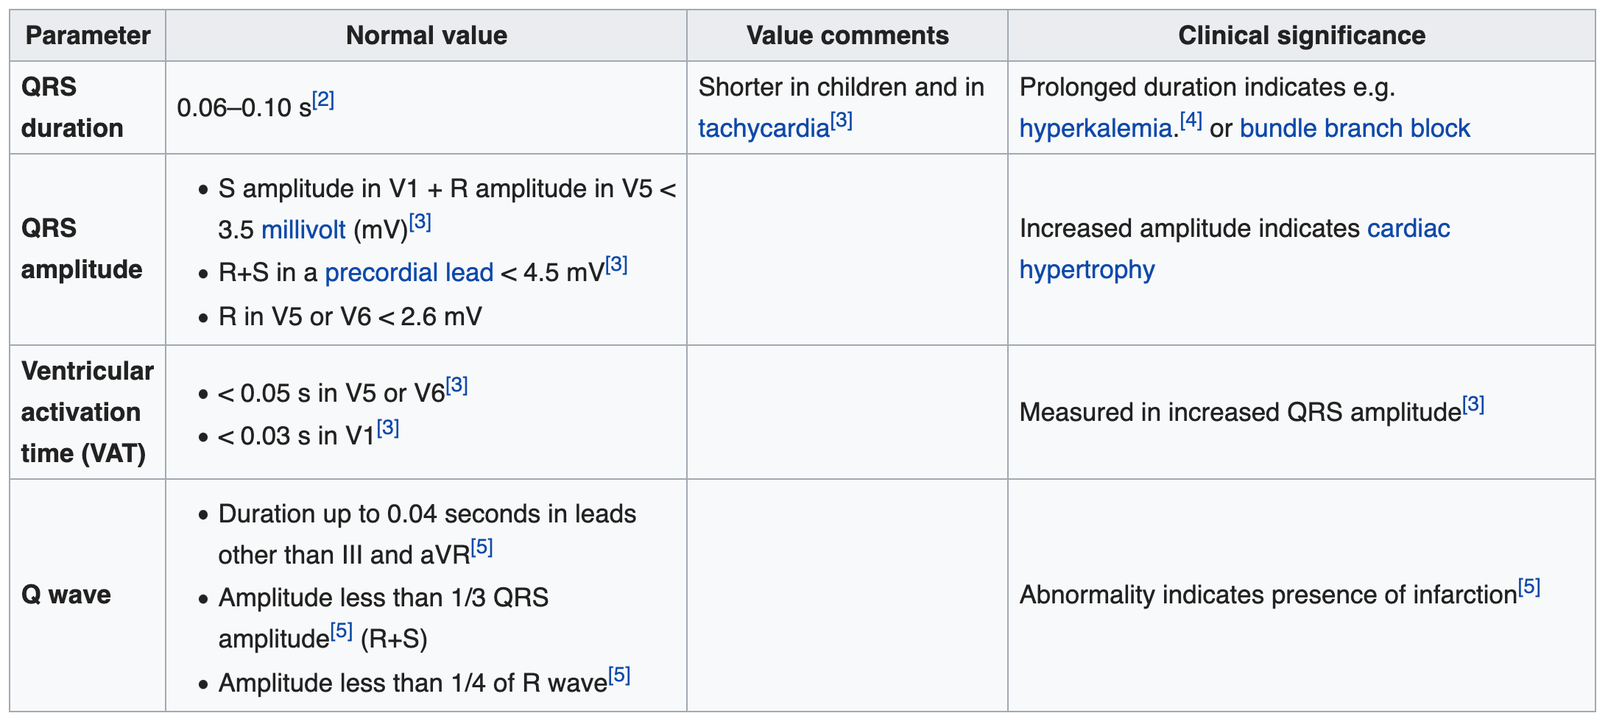

**The Role of Sloppy Data:**

In a 12-lead ECG, all leads except the limb leads are unipolar (aVR, aVL, aVF, V1, V2, V3, V4, V5, and V6). The measurement of a voltage requires two contacts and so, electrically, the unipolar leads are measured from the common lead (negative) and the unipolar lead (positive). This averaging for the common lead and the abstract unipolar lead concept makes for a more challenging understanding and is complicated by sloppy usage of "lead" and "electrode"

Medical assessment of the abnormality using an [electrocardiogram](https://en.wikipedia.org/wiki/Electrocardiogram) is one way to diagnose and assess the risk of any given arrhythmia.

Evidence does not support the use of ECGs among those without symptoms or at low risk of [cardiovascular disease](https://en.wikipedia.org/wiki/Cardiovascular_disease) as an effort for prevention.[[12]](https://en.wikipedia.org/wiki/Electrocardiography#cite_note-13)[[13]](https://en.wikipedia.org/wiki/Electrocardiography#cite_note-Annals2012-14)[[14]](https://en.wikipedia.org/wiki/Electrocardiography#cite_note-whenyouneedEKGs-15) This is because an ECG may falsely indicate the existence of a problem, leading to [misdiagnosis](https://en.wikipedia.org/wiki/Misdiagnosis)

**Cures for Arrhythmia:**

physical maneuvers, drugs, electricity, electrophysiology. (fine probes inserted through the blood vessels to map electrical activity from within the heart. This allows abnormal areas of conduction to be located very accurately and subsequently destroyed by heat, cold, electrical, or laser probes)

In the 1960s and 1970s problems with antihistamines and antipsychotics were discovered.[[27]](https://en.wikipedia.org/wiki/Arrhythmia#cite_note-Hei2010-27) It was not until the 1980s that the underlying issue, [QTc prolongation](https://en.wikipedia.org/wiki/QT_interval#Abnormal_intervals) was determined

**Common Features in Arrhythmia datasets:**

The main thing in common is the pattern of the EKG broken up into the 5 parts -PQRST. There are also some J, U, R’_wave, S’_wave etc. but those are not as prevelant in the data.

Most data contained: age, sex, height, weight, heart rate, then the pattern of the EKG broken out, ex: QRS duration, PR interval, QT interval,T iterval, P interval, T, P, J, q_wave, r_wave, s_wave, r’wave ,and s’wave.

So it is much like digital number recognition where lots of characteristics are used to describe one image. I actually tried a subset of data that just had these features, but it did not do any better than the full set of features.

**Talking to a Tech about EKGs and what to look for:**

I looked at 5 data sets that dealt with arrhythmia/heart data. The contained many, many features (up to 280). I was not planning on using all of them in my ML application. And was going to try to make sense of them and just pull out the ones that seemed to be important by learning all I could about the data on an EKG and how it is used. To do this, I had to research arrhythmias and how to interpret EKGs enough to understand what the features in the databases portrayed. I was able to talk to Alex Stone, a technician working at UTMB on Highway 3, who monitors EKG readings and informs doctors and nurses when he sees something anomalous. Talking to him made me realize how much of the human element is put into interpreting the EKGs, particularly if a patient moves. When a person moves the EKGs will spike and technicians can tell by how long they spike, what they know about the patient, etc. to help them determine if it is just the person moving around, or if something needs further attention.

A person normally has 5 – 12 leads attached at different locations on their body that all provide an EKG pattern. And the EKGs are continuous. The datasets I have investigated are a single snapshot of one EKG per row of data, along with the diagnosis. The technician can watch just one lead, or many leads attached to one person. In addition, they typically watch anywhere from 3 or 4 up to about 35 people at a given time. The technicians sit together in a room and monitor the EKGs on screens. They can ask each other if they see something anomalous, and they follow a predefined procedure of who to call when they see something anomalous. They typically work 12 hour shifts, but not all of that time is sitting in front of screens, although sometimes it can be (they are allowed to take breaks). It generally takes about two semesters to learn how to read an EKG properly.

I asked if just watching one lead was good enough, that is if one EKG is looking anomalous, do the other follow suit? Or are they all independent? He said it all depends, sometimes they do, but sometimes they don’t.

I also asked if there were many false positives (or false negatives) and he was not sure how to quantify that data since he doesn’t always follow up, he just reports.

**Electrocardiograms can diagnose:**

* Abnormally fast or irregular heart rhythms
* Abnormally slow heart rhythms
* Abnormal conduction of cardiac impulses, which may suggest underlying cardiac or metabolic disorders
* Evidence of the occurrence of a prior [heart attack](https://www.medicinenet.com/heart_attack/article.htm) ([myocardial infarction](https://www.medicinenet.com/heart_attack/article.htm))
* Evidence of an evolving, acute heart attack
* Evidence of an acute impairment to blood flow to the heart during an episode of a threatened heart attack (unstable [angina](https://www.medicinenet.com/angina_symptoms/article.htm))
* Adverse effects on the heart from various heart diseases or systemic diseases (such as [high blood pressure](https://www.medicinenet.com/high_blood_pressure_hypertension/article.htm), thyroid conditions, etc.)
* Adverse effects on the heart from certain lung conditions (such as [emphysema](https://www.medicinenet.com/emphysema_lung_condition/article.htm), pulmonary embolus [[blood clots](https://www.medicinenet.com/blood_clots/article.htm) to lung])
* Certain congenital heart abnormalities
* Evidence of abnormal blood [electrolytes](https://www.medicinenet.com/electrolytes/article.htm) (potassium, calcium, magnesium)
* Evidence of inflammation of the heart or its lining ([myocarditis](https://www.medicinenet.com/myocarditis/article.htm), [pericarditis](https://www.medicinenet.com/pericarditis/article.htm))

### **What are the limitations of the ECG (EKG)?**

1. The EKG is a static picture and may not reflect severe underlying heart problems at a time when the patient is not having any symptoms. The most common example of this is in a patient with a history of intermittent [chest pain](https://www.medicinenet.com/chest_pain/symptoms.htm) due to severe underlying [coronary artery disease](https://www.medicinenet.com/heart_disease_coronary_artery_disease/article.htm). This patient may have an entirely normal EKG at a time when he or she is not experiencing any symptoms. In such instances, the EKG as recorded during an [exercise](https://www.medicinenet.com/exercise/article.htm) [stress](https://www.medicinenet.com/stress/article.htm) test may reflect an underlying abnormality while the EKG taken at rest may be normal.
2. Many abnormal patterns on an EKG may be nonspecific, meaning that they may be observed with a variety of different conditions. They may even be a normal variant and not reflect any abnormality at all. These conditions can often be sorted out by a physician with a detailed examination, and occasionally other cardiac tests (for example, [echocardiogram](https://www.medicinenet.com/echocardiogram/article.htm), [exercise](https://www.medicinenet.com/exercise_and_fitness_quiz/quiz.htm) [stress](https://www.medicinenet.com/stress_symptoms_and_signs/symptoms.htm) test).
3. In some instances, the EKG may be entirely normal despite the presence of an underlying cardiac condition that normally would be reflected in the EKG. The reasons for this are largely unknown, but it is important to remember that a normal EKG does not necessarily preclude the possibility of underlying [heart disease](https://www.medicinenet.com/heart_disease_pictures_slideshow_visual_guide/article.htm). Furthermore, a patient with [heart symptoms](https://www.medicinenet.com/heart_health_pictures_slideshow/article.htm) can frequently require additional evaluation and testing.

**UNDERSTANDING THE SAMPLE SETS:   
arrhythmia.csv from http://mlr.cs.umass.edu/ml/datasets/Arrhythmia**

Sample of Arrhythmia.csv:

Number of Instances: 452

Number of Attributes: 279

? – means missing data

Last number is target .e.g. 8 represents an arrhythmia case

Concerning the study of H. Altay Guvenir: "The aim is to distinguish between the presence and absence of cardiac arrhythmia and to classify it in one of the 16 groups. Class 01 refers to 'normal' ECG classes 02 to 15 refers to different classes of arrhythmia and class 16 refers to the rest of unclassified ones. For the time being, there exists a computer program that makes such a classification. However there are differences between the cardiolog's and the programs classification. Taking the cardiolog's as a gold standard we aim to minimise this difference by means of machine learning tools."

Attribute Information:

1-4:

75 age

0 male

190 height (cm) = 6.2 feet

80 weight (kilogram) = 176 lbs,

5-9:

91 (msec) avg QRS duration,

193 (msec) avg duration between onset of P and Q waves,

371 (msec) avg duration between onset of Q and T waves,

174 (msec) avg duration of T wave,

121 (msec) avg duration of P wave,

10-14:

-16 (degrees) avg angle of QRS wave,

13 (degrees) avg angle of T wave,

64 (degrees) avg angle of P wave,

-2 (degrees) avg angle of QRST wave,

? (degrees) avg angle of J wave,

15: 63 number of beats per min,

16-27: *** ON DI CHANNEL *** Then same but on channel DII, DIII, AVR, AVL, AVF, V1, V2, V3, V4, V5, V6 (LEADS)

0 (msec) width of Q wave,

52 (msec) width of R wave,

44 (msec) width of S wave,

0 (msec) width of R' wave,

0 (msec) width of S'wave,

32 number of intrinsic deflections,

0 Existence of ragged R wave, nominal

0 Existence of diphasic derivation of R wave, nominal

0 Existence of ragged P wave, nominal

0 Existence of diphasic derivation of P wave, nominal

0 Existence of ragged T wave, nominal

0 Existence of diphasic derivation of T wave, nominal

0, 52, 44, 0, 0, 32, 0, 0, 0, 0, 0, 0, DI

0, 44, 20, 36, 0, 28, 0, 0, 0, 0, 0, 0, DII

52, 40, 0, 0, 0, 60, 0, 0, 0, 0, 0, 0, DIII

52, 0, 0, 0, 0, 0, 0, 0, 0, 0, 0, 0, AVR

0, 56, 36, 0, 0, 32, 0, 0, 0, 0, 0, 0, AVL

48, 32, 0, 0, 0, 56, 0, 0, 0, 0, 0, 0, AVF

80, 0, 0, 0, 0, 0, 0, 0, 0, 0, 0, 0, V1

0, 40, 52, 0, 0, 28, 0, 0, 0, 0, 0, 0, V2

0, 48, 48, 0, 0, 32, 0, 0, 0, 0, 0, 0, V3

0, 52, 52, 0, 0, 36, 0, 0, 0, 0, 0, 0, V4

0, 52, 48, 0, 0, 32, 0, 0, 0, 0, 0, 0, V5

0, 56, 44, 0, 0, 32, 0, 0, 0, 0, 0, 0, V6

160-169: *** ON DI CHANNEL *** Then same but on channel DII, DIII, AVR, AVL, AVF, V1, V2, V3, V4, V5, V6 (LEADS)

-0.2 Amplitude , * 0.1 milivolt, of JJ wave, linear

0.0 Amplitude , * 0.1 milivolt, of Q wave, linear

6.1 Amplitude , * 0.1 milivolt, of R wave, linear

-1.0 Amplitude , * 0.1 milivolt, of S wave, linear

0.0 Amplitude , * 0.1 milivolt, of R' wave, linear

0.0 Amplitude , * 0.1 milivolt, of S' wave, linear

0.6Amplitude , * 0.1 milivolt, of P wave, linear

2.1 Amplitude , * 0.1 milivolt, of T wave, linear

13.6 QRSA , Sum of areas of all segments divided by 10, ( Area= width * height / 2 ), linear

30.8 QRSTA = QRSA + 0.5 * width of T wave * 0.1 * height of T wave. (If T is diphasic then the bigger segment is considered), linear

-0.2, 0.0, 6.1, -1.0, 0.0, 0.0, 0.6, 2.1, 13.6, 30.8, DI

0.0, 0.0, 1.7, -1.0, 0.6, 0.0, 1.3, 1.5, 3.7, 14.5, DII

0.1, -5.2, 1.4, 0.0, 0.0, 0.0, 0.8, -0.6, -10.7, -15.6, DIII

0.4, -3.9, 0.0, 0.0, 0.0, 0.0, -0.8, -1.7, -10.1, -22.0, AVR

0.0, 0.0, 5.7, -1.0, 0.0, 0.0, -0.1, 1.2, 14.1, 22.5, AVL

0.0, -2.5, 0.8, 0.0, 0.0, 0.0, 1.0, 0.4, -4.8, -2.7, AVF

0.1, -6.0, 0.0, 0.0, 0.0, 0.0, -0.8, -0.6, -24.0, -29.7, V1

0.0, 0.0, 2.0, -6.4, 0.0, 0.0, 0.2, 2.9, -12.6, 15.2, V2

-0.1, 0.0, 8.4,-10.0, 0.0, 0.0, 0.6, 5.9, -3.9, 52.7, V3

-0.3, 0.0, 15.2, -8.4, 0.0, 0.0, 0.9, 5.1, 17.7, 70.7, V4

-0.4, 0.0, 13.5, -4.0, 0.0, 0.0, 0.9, 3.9, 25.5, 62.9, V5

-0.3, 0.0, 9.0, -0.9, 0.0, 0.0, 0.9, 2.9, 23.3, 49.4, V6

DIAGNOSIS: 8

**UNDERSTANDING THE SAMPLE SETS:**

**data_arrhythmia.csv from https://www.kaggle.com/bulentesen/cardiac-arrhythmia-database**

Sample of data_arrhythmia.csv:

Number of Instances: 453

Number of Attributes: 280

Missing data

Features:

age

sex

height

weight

qrs_duration

p-r_interval

q-t_interval

t_interval

p_interval

qrs

T

P

QRST

J

heart_rate

q_wave

r_wave

s_wave

R'_wave

S'_wave

AA

AB

AC

AD

AE

AF

AG

AH

AI

AJ

AK

AL

AM

AN

AO

AP

AR

AS

AT

AU

AV

AY

AZ

AB'

BB

BC

BD

BE

BF

BG

BH

BI

BJ

BK

BL

BM

BN

BO

BP

BR

BS

BT

BU

BV

BY

BZ

CA

CB

CC

CD

CE

Cf

CG

CH

CI

CJ

CK

CL

CM

CN

CO

CP

CR

CS

CT

CU

CV

CY

CZ

DA

DB

DC

DD

DE

DF

DG

DH

DI

DJ

DK